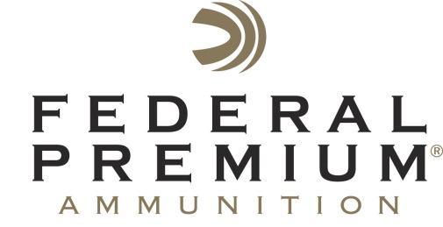
Contact: JJ Reich
Public Relations Specialist
763-323-3862
FOR IMMEDIATE RELEASE E-mail: pressroom@atk.com

Federal Premium Will Host Shooting Sports Celebrities at the
2015 SHOT Show in Las Vegas

Federal Premium® welcomes professional shooter Julie Golob, TV host Chad Belding from “The Fowl Life,” country music singing sensation Drake White, and YouTube fan favorite Hickok45 to the ATK Sporting Group booth at the 2015 SHOT Show in Las Vegas, Jan. 20-23. The celebrities will be on hand to meet show attendees and discuss their favorite products used in the field and on the range.

ANOKA, Minn. – January 15 – 2015 Federal Premium® Ammunition is pleased to invite attendees of the 2015 SHOT Show to the ATK Sporting Group booth (#14551) in Las Vegas, Jan. 20-23. Attendees will have the opportunity to meet professional shooter Julie Golob, Chad Belding, host of the popular TV show “The Fowl Life”, country music singer Drake White and famed online personality Hickok45.

Golob is a world champion shooter and author with a passion for the outdoors. She will be in the ATK Sporting Group booth to sign autographs, share shooting tips and answer questions from fans on Tuesday, Jan. 20 from 10 to 11 a.m. and Wednesday, Jan. 21 from 12 to 1 p.m.

Belding is a passionate and highly experienced waterfowl hunter. While visiting the booth, he’ll discuss the role that specialized Federal Premium Black Cloud® loads play in his hunts. Belding will be in the ATK Sporting Group booth on Tuesday, Jan. 20 from 4 to 5 p.m. to introduce a new Black Cloud commercial and singer/songwriter Drake White.

White is a rising star in country music and was recently tagged by Billboard Magazine as one of the top 10 country artists to watch. He is an avid outdoorsman and is often found in the field or on the water when not on tour. White will be at the ATK Sporting booth on Tuesday, Jan. 20 from 4 to 5 p.m. to perform live music.

Hickok45 is YouTube fan favorite with more than 1.3 million subscribers to his channel. His videos have been watched more than 300 million times and his popularity continues to soar. Hickok45 will be in the ATK Sporting Group booth on Friday, Jan. 23 from 10 a.m. to noon to sign autographs and answer questions from fans.

Attendees are encouraged to stop by the ATK Sporting Group booth at the 2015 SHOT Show to visit their favorite celebrities and learn more about the latest products offered by Federal Premium.

To view the lineup of Federal Premium Ammunition, please visit www.federalpremium.com.

